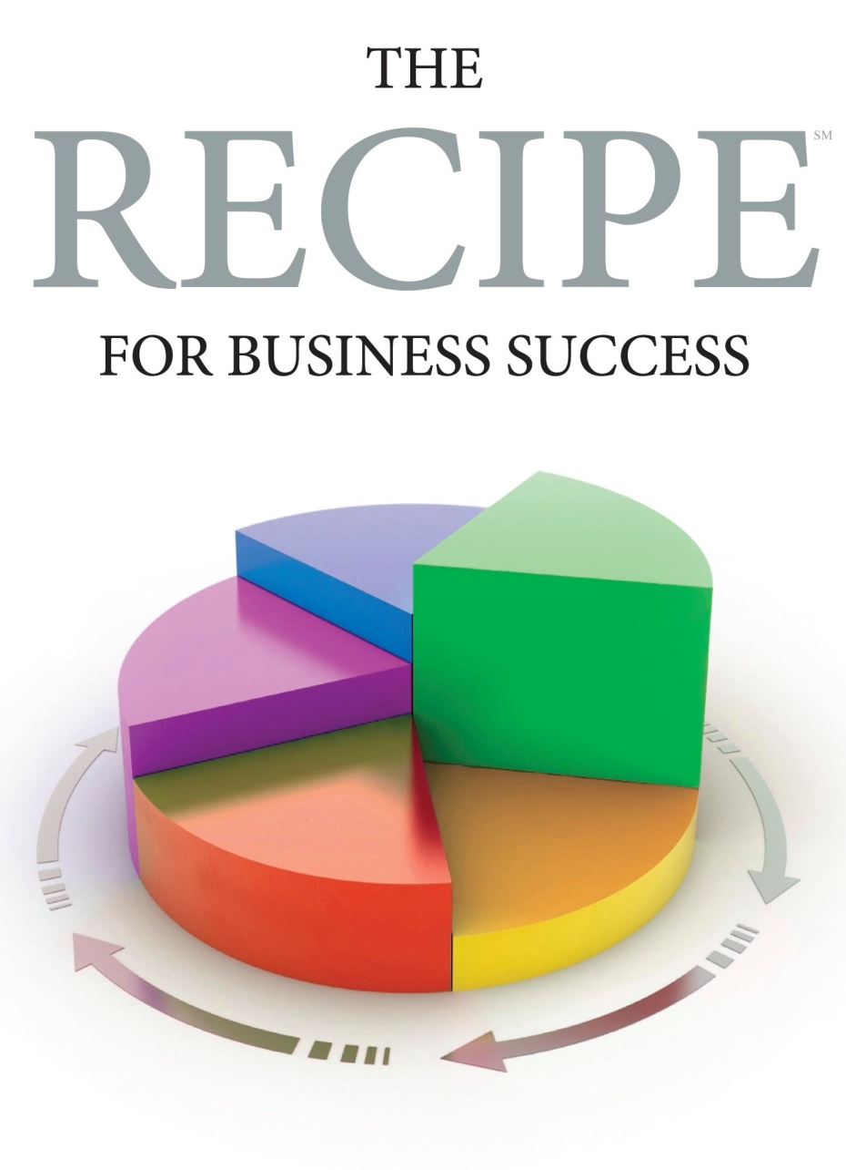
Marketing Director / Manager: _____________________Date: _______
Questions | Notes | Score 1-5
Please describe marketing – what functions and responsibilities does it include?
Please describe the role marketing should play in a business’s direction?
Please describe the role marketing should play in the selling process?
What is a brand and how are they built?
How are brands sustained?
Name the components of a marketing plan?
Comment on the major challenges for marketing in today’s environment?
Please describe your experience in the following areas:
Public presentations?
Traditional marketing communications?
Social marketing communications?
Convention / trade show marketing?
Writing / editing?
Writing complete marketing plans?
Budget creation / management?
Market identification / validation?
Marketing in our specific industry?
How would you describe your detail orientation?
Please describe your performance at your past two positions – successes and failures?
Please describe your largest career marketing failure and what you learned from it.
Please describe how you measure your marketing program effectiveness.
What type of leadership do you like best? Worst? Why?
What are your strengths?
What are your weaknesses?
What are your five year goals?
Why are you interested in this position?
Other points:
Personal communication skills
Portfolio review (they should have one)
Professional appearance / presentation
Second interview marketing presentation
Screening tool summary
References
 | Total

