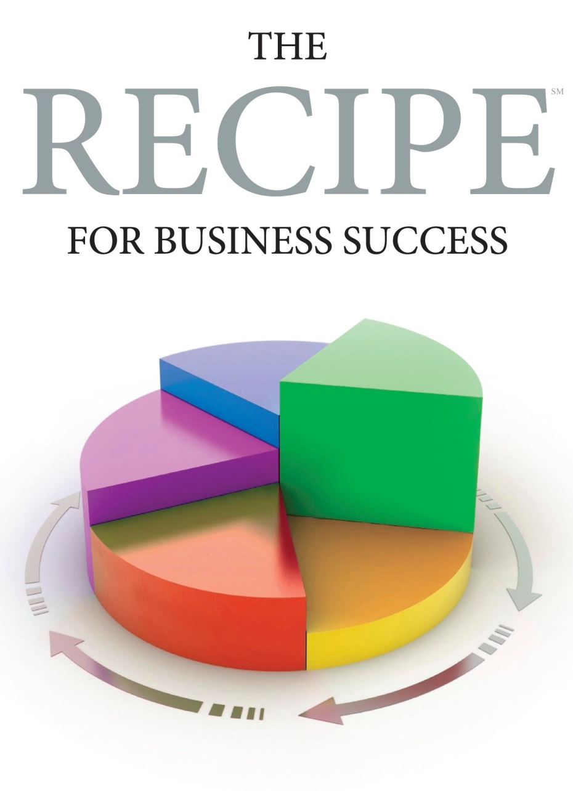
PRODUCT DEVELOPMENT PROCESS
Revision January 2010

Phase 0
Written request
Feasibility:
Sales
PM
Refined written spec
Business case study:
S & M
PM
Eng.
Oper.
Create MRD
PM
Eng.
Present MRD for approval
S & M
PM
Eng.
Oper.
Engineering design approach
Design approach review:
Eng.
PM
Oper.
Detailed Design:
Eng.
Engineering Peer review
Revise as needed
Design review:
Eng.
PM
Oper.
Production Review:
Eng
Oper.
PM
Prototype:
Eng.
Product Design Release
Training:
Sales
TS
Initial build
Sales & Delivery
KEY
Phase 1
Phase 2
Phase 3
Phase 4
Phase 5
Idea
Stop project
PM Product Manager
TS Technical Service
S&M Sales & Marketing

