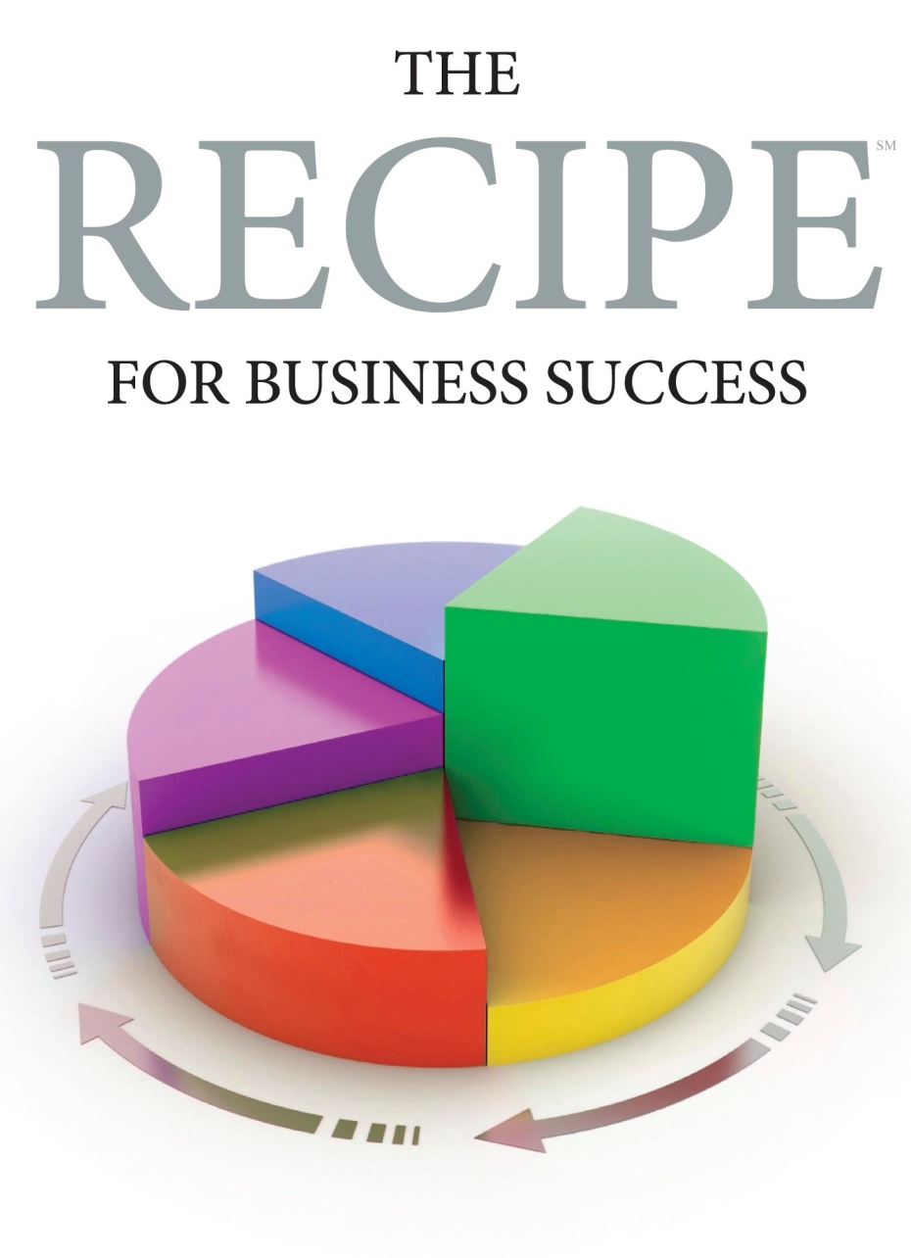
Job Description
Sales Representative

(Company name) is looking for a seasoned sales representative to drive business expansion. (Company name) provides (insert description of business). Founded in ______, (company name) has shown consistent growth and is well financed (modify as applicable). The ideal candidate will have proven experience as a (small, medium, large) new account sales representative.

Responsibilities:
This position reports to the (insert title) and will have responsibility for sales functions in the (insert) region/territory. This person will work as part of a three-person sales team with common goals (modify based upon your structure). Responsibilities include:
- Identification, development, and acquisition of new customers.
- Securing additional sales from existing customers, as well as the maintenance of such customer relationships.
- Establishment and daily management of a prospect sales-funnel program. They will establish and manage the key milestones needed to qualify a prospect or bring the order to a close.
- Establishment of monthly, quarterly, and annual sales forecasts.
- Performance to sales quotas on a monthly, quarterly, and annual basis.
- Weekly sales funnel progress reporting.
- Management of a travel and entertainment budget.
- Customer input to marketing regarding product and service improvements as identified from prospect contact.
- (Other as required)

Required Skills & Experience:
- Five or more years of proven regional / national direct B to B new customer selling experience in the (insert) or related industry.
- Proven experience developing and maintaining (small, medium, large) account relationships.
- Able to provide annual sales performance to quota for all years of experience.
- Able to describe the process by which they were successful.
- Proven experience developing and managing travel and entertainment budgets
- (Other as required)

Like to have experience:
- Proven selling experience specifically in the (insert) industry
- Ten or more years of proven field sales experience
- (Other as desired)

Compensation:
- Salary plus incentive compensation program
- Medical and dental insurance
- 401k program with company match
- Company vehicle (or car allowance)
- Paid holidays and vacation

