THE

RECIPE

SM

FOR BUSINESS SUCCESS



***Audio Book***

***Charts and Visuals***

Strategic Fit



US Patent #6,293,874

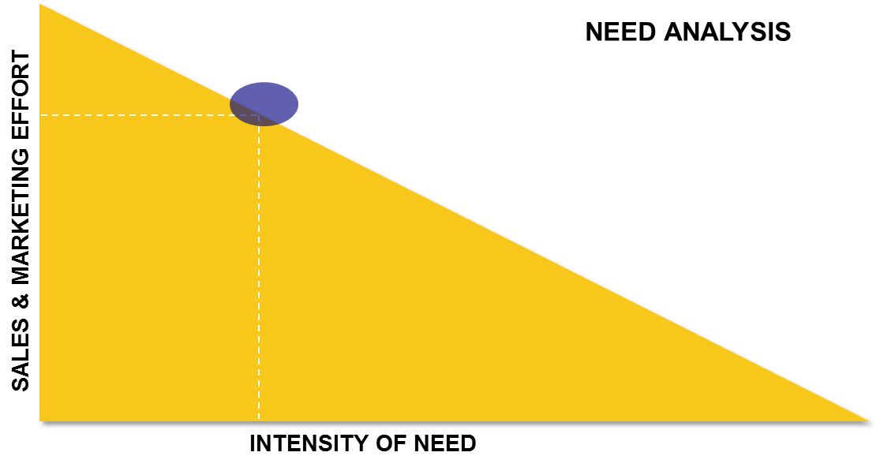

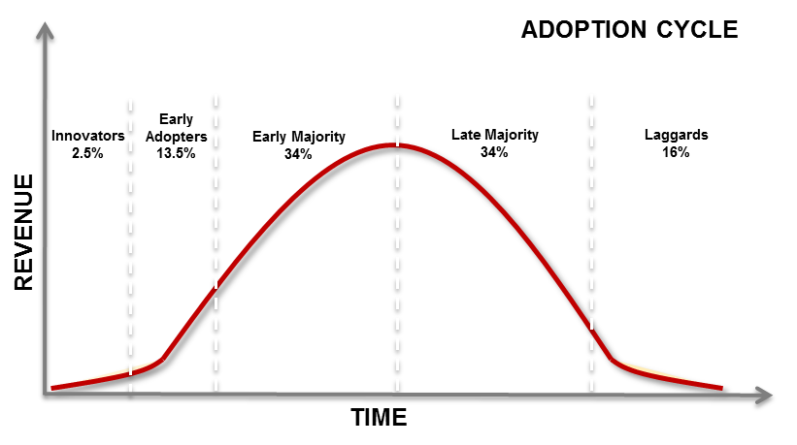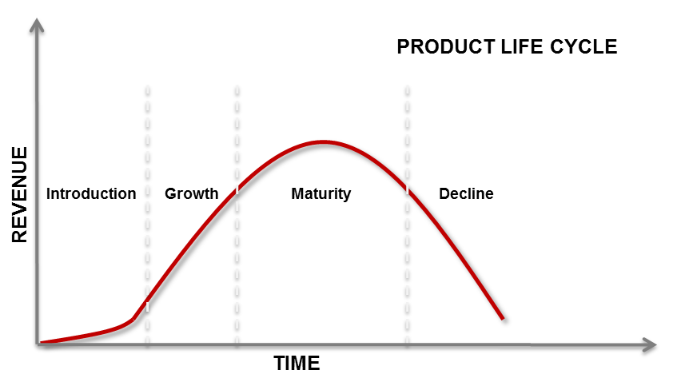

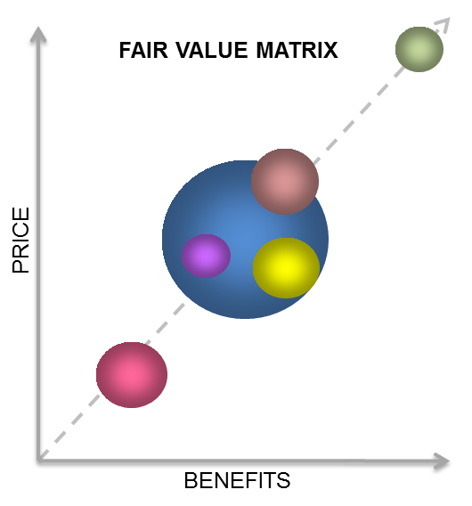

Report Card

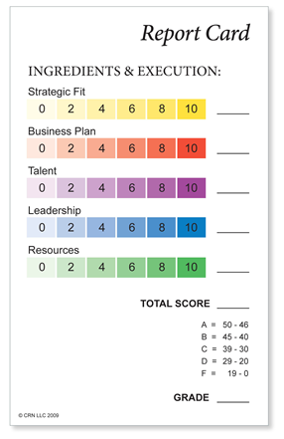

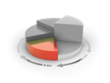Business Plan

|  |  |  |  |  |  |  |
| --- | --- | --- | --- | --- | --- | --- |
| Year | 2015 act | 2016 act | 2017 act | 2018 pro | 2019 pro | 2020 pro |
| Revenue | $1,000 | $2,000 | $4,000 | $6,000 | $10,000 | $15,000 |
| COGS | 40% | 40% | 45% | 45% | 45% | 45% |
| GM | 60% | 60% | 55% | 55% | 55% | 55% |
| Expenses |  |  |  |  |  |  |
| Sales and Marketing | 20% | 20% | 22% | 21% | 20% | 20% |
| Development | 8% | 10% | 10% | 10% | 10% | 10% |
| Support | 6% | 6% | 6% | 6% | 6% | 6% |
| IT | 2% | 2% | 2% | 2% | 2% | 2% |
| Warranty | 1% | 1% | 1% | 1% | 1% | 1% |
| G&A | 6% | 6% | 6% | 7% | 7% | 8% |
| Total Expenses | 43% | 45% | 47% | 47% | 46% | 47% |
| NOP | 17% | 15% | 8% | 8% | 9% | 8% |

**ACTION PLAN**

|  |  |  |
| --- | --- | --- |
| **JANUARY** |  |  |
| **Action** | **Responsible** | **Date required** |
| Advertisement in X magazine | Jim | 1/5 |
| Product X released to production | John | 1/15 |
| Sales rep for eastern region hired | Sue | 1/31 |
| New MRP system operational | Bill | 1/31 |
| Etc.. |  |  |

Talent

**Discipline: Capability & Experience:**

Sales: 0 or 5 Sales: 0,1,2,3,4,5

Marketing: 0 or 5 Marketing: 0,1,2,3,4,5

Development: 0 or 5 Development: 0,1,2,3,4,5

Operations: 0 or 5 Operations: 0,1,2,3,4,5

IT: 0 or 5 IT: 0,1,2,3,4,5

Finance: 0 or 5 Finance: 0,1,2,3,4,5

**Grade Scale: Total Score: _________**

55 – 60 = A

48 – 54 = B **Grade: ________**

42 – 47 = C

36 – 41 = D

< 36 = F

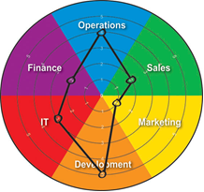

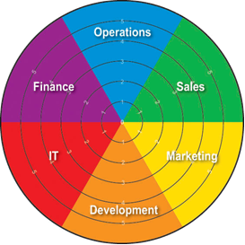

**Interview Questionnaire (Marketing Manager Example)**

|  |  |  |
| --- | --- | --- |
| **QUESTION** | **NOTES** | **SCORE 1-5** |
| Overall presence and appearance |  |  |
| Please describe marketing. What functions and responsibilities does it include? |  |  |
| Please describe the role marketing should play in a business’ overall direction. |  |  |
| Please describe the role marketing should play in the selling process. |  |  |
| Can you describe how brands are built as well as sustained? |  |  |
| What are the major challenges for marketing in today’s environment? |  |  |
| Please describe your experience in the following areas: |  |  |
| Public presentations |  |  |
| Traditional marketing communications |  |  |
| Social marketing communications |  |  |
| Conventions and trade shows |  |  |
| Writing and editing |  |  |
| Written planning |  |  |
| Budget creation and management |  |  |
| Market identification and validation |  |  |
| Specific industry |  |  |
| How would you describe your detail orientation? |  |  |
| Please describe your performance at your past two positions; successes and failures. |  |  |
| What type of leadership do you like best? Why? |  |  |
| What are your strengths? |  |  |
| What are your weaknesses? |  |  |
| What are your five year goals and career goals? |  |  |
| Why do you want this job? |  |  |
| Also score on: |  |  |
| Overall communication ability |  |  |
| Portfolio review |  |  |
| Screening / references |  |  |
| Second interview |  |  |
| Notes and areas of concern: |  |  |
|  | Total |  |

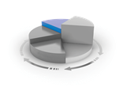Leadership

Below is a leadership self-test by A. J. Schuler, a renowned expert on leadership and team performance. Take the time right now to find out whether or not you possess the characteristics of a true leader. Below the test are answers that indicate whether your response is more like that of a leader or a manager.

|  |  |  |
| --- | --- | --- |
|  | **TRUE** | **FALSE** |
| * I think more about immediate results than I do about mentoring others. |  |  |
| * People will be motivated if you pay them enough. |  |  |
| * It’s nice to know about people’s long-term goals, but not necessary to get the job done. |  |  |
| * If you have a consistent recognition system that rewards everyone in the same way, then that is enough. |  |  |
| * The best way to build a team is to set a group goal that is highly challenging, maybe even “crazy.” |  |  |
| * My greatest pleasure in my job comes from making the work process more effective. |  |  |
| * I spend more of my time and attention on my weaker performers than I do on my top performers, who basically take care of themselves. |  |  |
| * It’s better not to know anything about the personal lives and interests of the people who report to me. |  |  |

|  |  |  |
| --- | --- | --- |
|  | **TRUE** | **FALSE** |
| * Sometimes, it’s almost as if I’m a “collector of people” because I’m always recruiting and getting to know new people. |  |  |
| * I like to surround myself with people who are better at what they do than I am. |  |  |
| * I am a lifelong student of what makes other people tick. |  |  |
| * People talk about “mission” too much – it’s best just to let people do their work and not try to bring values into the conversation. |  |  |
| * It’s my job to know everything that goes on in my area. |  |  |
| * I pay close attention to how and where I spend my time, because the priorities I put into action are the ones that other people will observe and follow. |  |  |
| * I’ve worked hard to get along with or understand people who are very different from me. |  |  |

ANSWERS

Leaders would most likely respond: F,F,F,F,T,F,F,F,T,T,T,F,F,T,T

Managers would most likely respond: T,T,T,T,F,T,T,T,F,F,F,T,T,F,F

Resources

**Profit**

**Time**

Proof Seed Startup Early Growth Maturing

(Please also download the Recipe Check Summary)